1. Create a new project🡪IITMVC1🡪No1.ASP.NET Web Application (.NET Framework) ASP.NET 4.6.1 🡪MVC🡪No Authentication
2. Introduce:

**App_data**: database

**App_start**:

RouteConfig.cs (web page setting)

using System.Web.Mvc;

using System.Web.Routing;

namespace IITMVC1

{

public class RouteConfig

{

public static void RegisterRoutes(RouteCollection routes)

{

routes.IgnoreRoute("{resource}.axd/{*pathInfo}");

routes.MapRoute(

name: "Default",

url: "{controller}/{action}/{id}",

defaults: new { controller = "Home", action = "Index", id = UrlParameter.Optional }

);

}

}

}

Controller:

using System;

using System.Collections.Generic;

using System.Linq;

using System.Web;

using System.Web.Mvc;

namespace IITMVC1.Controllers

{

public class HomeController : Controller

{

public ActionResult Index()

{

return View();

}

public ActionResult About()

{

ViewBag.Message = "Your application description page.";

return View();

}

public ActionResult Contact()

{

ViewBag.Message = "Your contact page.";

return View();

}

}

}

**Views:**

@{

ViewBag.Title = "Home Page";

}

<div class="jumbotron">

<h1>ASP.NET</h1>

<p class="lead">ASP.NET is a free web framework for building great Web sites and Web applications using HTML, CSS and JavaScript.</p>

<p><a href="http://asp.net" class="btn btn-primary btn-lg">Learn more &raquo;</a></p>

</div>

<div class="row">

<div class="col-md-4">

<h2>Getting started</h2>

<p>

ASP.NET MVC gives you a powerful, patterns-based way to build dynamic websites that

enables a clean separation of concerns and gives you full control over markup

for enjoyable, agile development.

</p>

<p><a class="btn btn-default" href="http://go.microsoft.com/fwlink/?LinkId=301865">Learn more &raquo;</a></p>

</div>

<div class="col-md-4">

<h2>Get more libraries</h2>

<p>NuGet is a free Visual Studio extension that makes it easy to add, remove, and update libraries and tools in Visual Studio projects.</p>

<p><a class="btn btn-default" href="http://go.microsoft.com/fwlink/?LinkId=301866">Learn more &raquo;</a></p>

</div>

<div class="col-md-4">

<h2>Web Hosting</h2>

<p>You can easily find a web hosting company that offers the right mix of features and price for your applications.</p>

<p><a class="btn btn-default" href="http://go.microsoft.com/fwlink/?LinkId=301867">Learn more &raquo;</a></p>

</div>

</div>

Shared:

_Layout.cshtml (show the home page)

<!DOCTYPE html>

<html>

<head>

<meta charset="utf-8" />

<meta name="viewport" content="width=device-width, initial-scale=1.0">

<title>@ViewBag.Title - My ASP.NET Application</title>

@Styles.Render("~/Content/css")

@Scripts.Render("~/bundles/modernizr")

</head>

<body>

<div class="navbar navbar-inverse navbar-fixed-top">

<div class="container">

<div class="navbar-header">

<button type="button" class="navbar-toggle" data-toggle="collapse" data-target=".navbar-collapse">

<span class="icon-bar"></span>

<span class="icon-bar"></span>

<span class="icon-bar"></span>

</button>

@Html.ActionLink("Application name", "Index", "Home", new { area = "" }, new { @class = "navbar-brand" })

</div>

<div class="navbar-collapse collapse">

<ul class="nav navbar-nav">

<li>@Html.ActionLink("Home", "Index", "Home")</li>

<li>@Html.ActionLink("About", "About", "Home")</li>

<li>@Html.ActionLink("Contact", "Contact", "Home")</li>

</ul>

</div>

</div>

</div>

<div class="container body-content">

@RenderBody()

<hr />

<footer>

<p>&copy; @DateTime.Now.Year - My ASP.NET Application</p>

</footer>

</div>

@Scripts.Render("~/bundles/jquery")

@Scripts.Render("~/bundles/bootstrap")

@RenderSection("scripts", required: false)

</body>

</html>

1. Add new model

Add🡪ADO.NET Entity Data Model (using exists database)

Create a localdb:

<https://msdn.microsoft.com/en-us/library/hh212961.aspx>

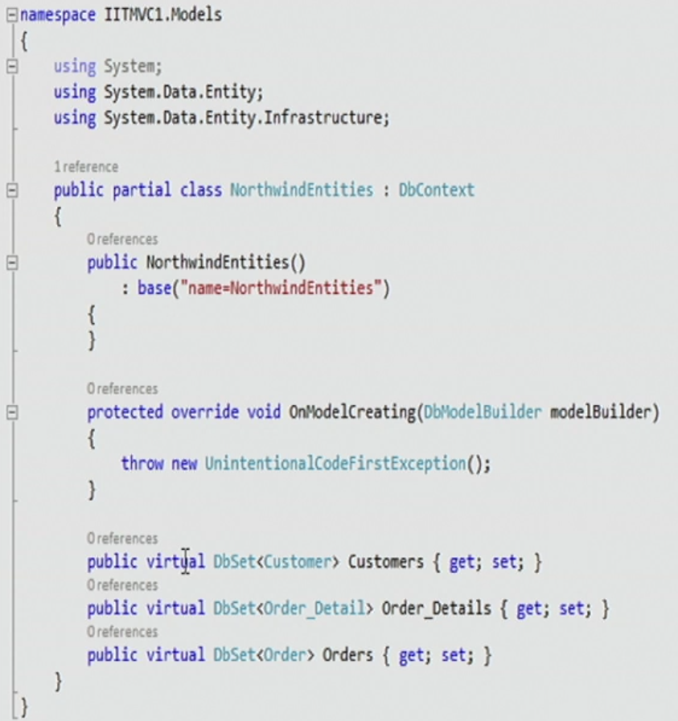

1. Add new controller:

Add new🡪add new scaffolded item🡪 MVC5 Controller with views, using Entity Framework

1. To view this controller, go to view folder, create a new view and update index view.

